**West Coast Collaborative**

**Specialist Mathematics Units 3 & 4**

**Test 3 2018**

**Calculator Free Section**

**Name: __________________________ Score: _____ / 22**

**Time Allowed**: 22 minutes

**No calculators or notes are to be used.**

**Access to approved Mathematics Specialist formulae sheet is permitted.**

Where a question or part of a question is worth more than 2 marks sufficient working to justify your solution is required.

**1. [ 4 marks ]**

MNOPQRST is a rectangular prism with **OP = *p***, **ON = *n* and OS = *s*.**

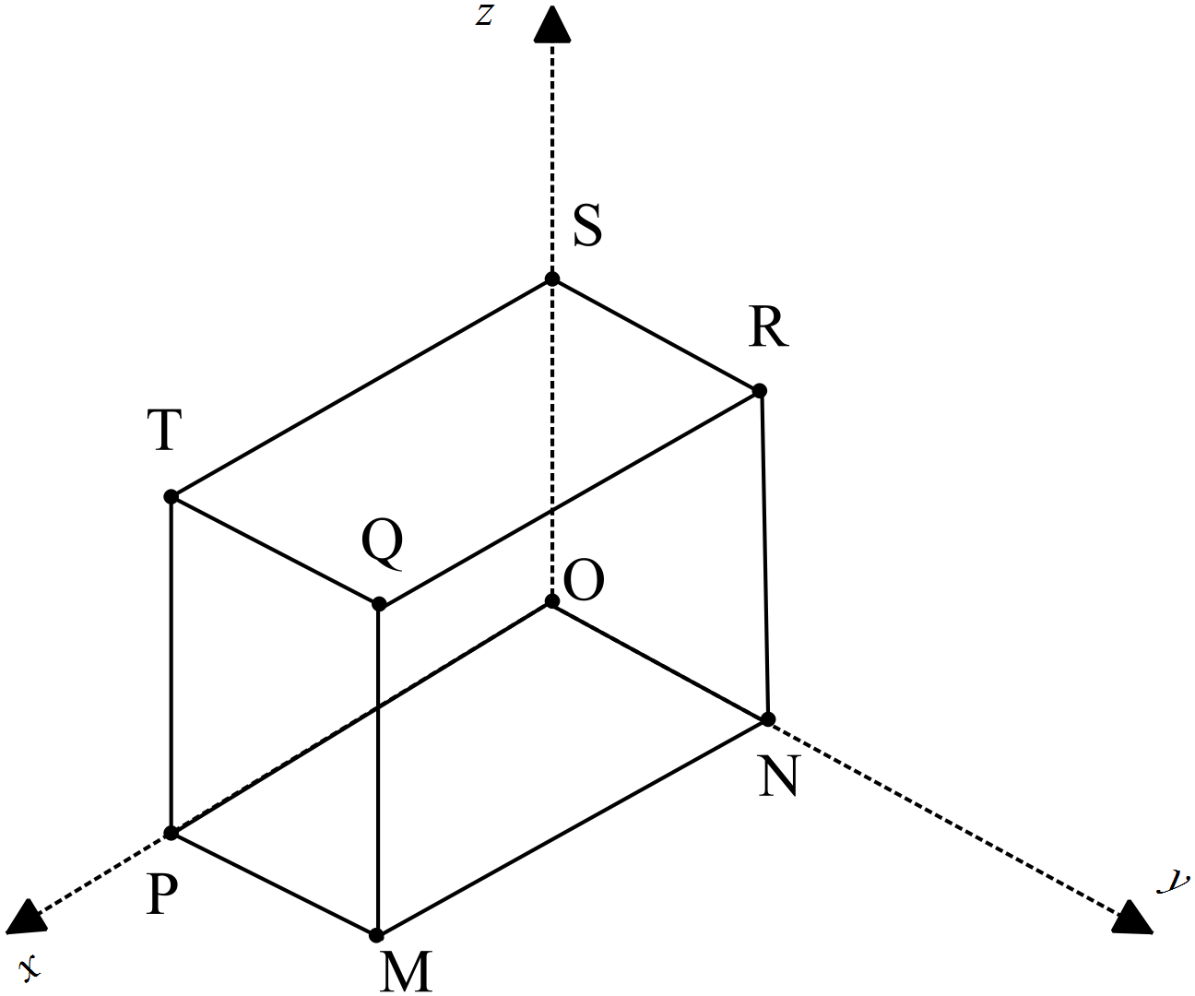

**O** is the origin of the ***x***-***y***-***z*** axes.

Use the fact that $a×b=\left|a\right|\left|b\right|sinθ$ and $a.b= \left|a\right|\left|b\right|cosθ$**to** prove that the volume of the cuboid is $\left|\left(p×n\right).s\right|$

**2.** **[ 5,1 = 6 marks]**

A plane Γ contains the points P at position **k –** 2**j,** Q at 4**i** + **j** +3**k** and R at 2**k** – **i.**

**a)** Determine a vector equation which contains the normal to the plane.

**b)** Express this as a Cartesian equation.

**3. [1, 1, 3 = 5 marks ]**

A point P moves in a path according to the parametric equations: $x=2\cos{t}, y=3\sin{t , }$ where $t≥0$

1. State the Cartesian equation of the path

1. State the velocity vector of the ellipse

1. Draw the path traced by P on the graph, indicating its direction and key points clearly.

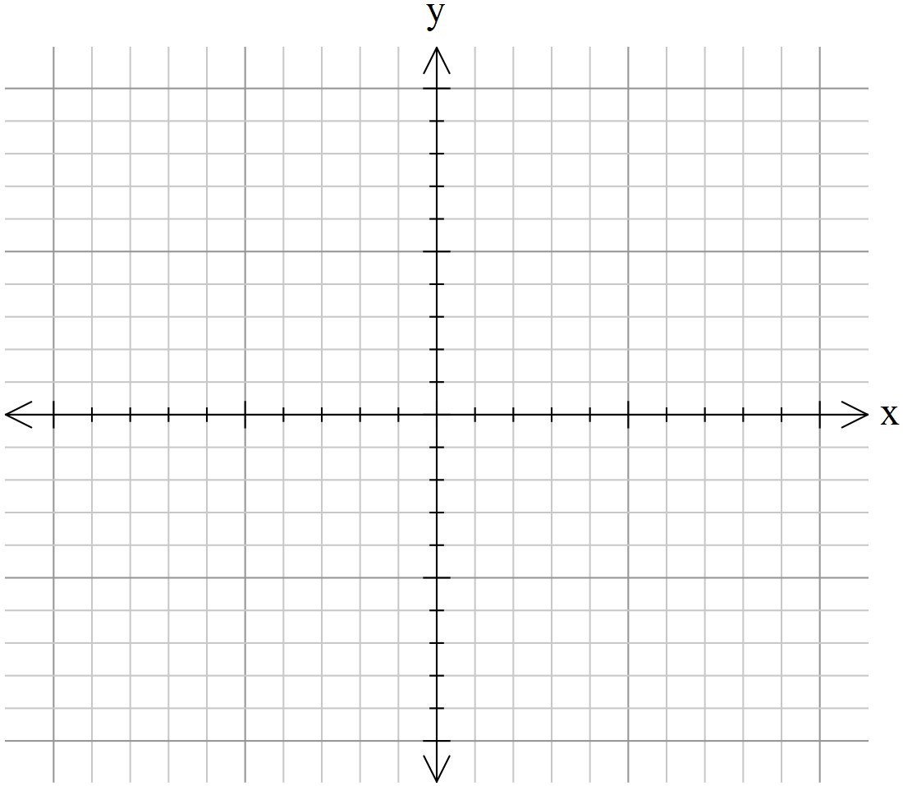

**4. [4, 1, 2 = 7marks]**

|  |  |  |  |  |  |  |
| --- | --- | --- | --- | --- | --- | --- |
| x | + | 3y | - | z | = | 5 |
| 2x | + | 7y | - | 3z | = | 6 |
| -x | - | y | + | (p2-p-1)z | = | p-13 |

For what value of p will the above system of equations have:

1. an infinite number of solutions,
2. no solutions
3. a unique solution?

**END OF PAPER**

**West Coast Collaborative**

**Specialist Mathematics Units 3 & 4**

**Test 3 2018**

**Calculator Assumed Section**

**Name: _______________________ Score: _____ / 33**

**Time Allowed**: 33 minutes **Total Marks**: 33

**Materials Allowed**: SCSA formula booklet, SCSA approved calculators and one A4 page of notes (both sides).

**Instructions:** Where a question or part of a question is worth more than 2 marks sufficient working to justify your solution is required.

5. [1,1,3,4 = 9 marks ]

The Cartesian equation of plane ∏ is .

**a)** State a vector equation of this plane.

The parametric equations of line  are .

**b)** State a vector equation for line .

**c)** Determine the position vector of , the point of intersection of line  and the plane.

**d)** Determine the acute angle between Line L and plane ∏ to the nearest tenth of a degree.

6. [ 5,3,4 = 12 marks]

For a particle projected from the Origin with speed µ ms-1 at an angle of $0<θ^{°} <90$ with the positive x-axis, the position vector at time $t$ seconds is $r\left(t\right)=ucosθti+\left(usinθt-5t^{2}\right)j$ metres. The equation of the path of the particle is given by

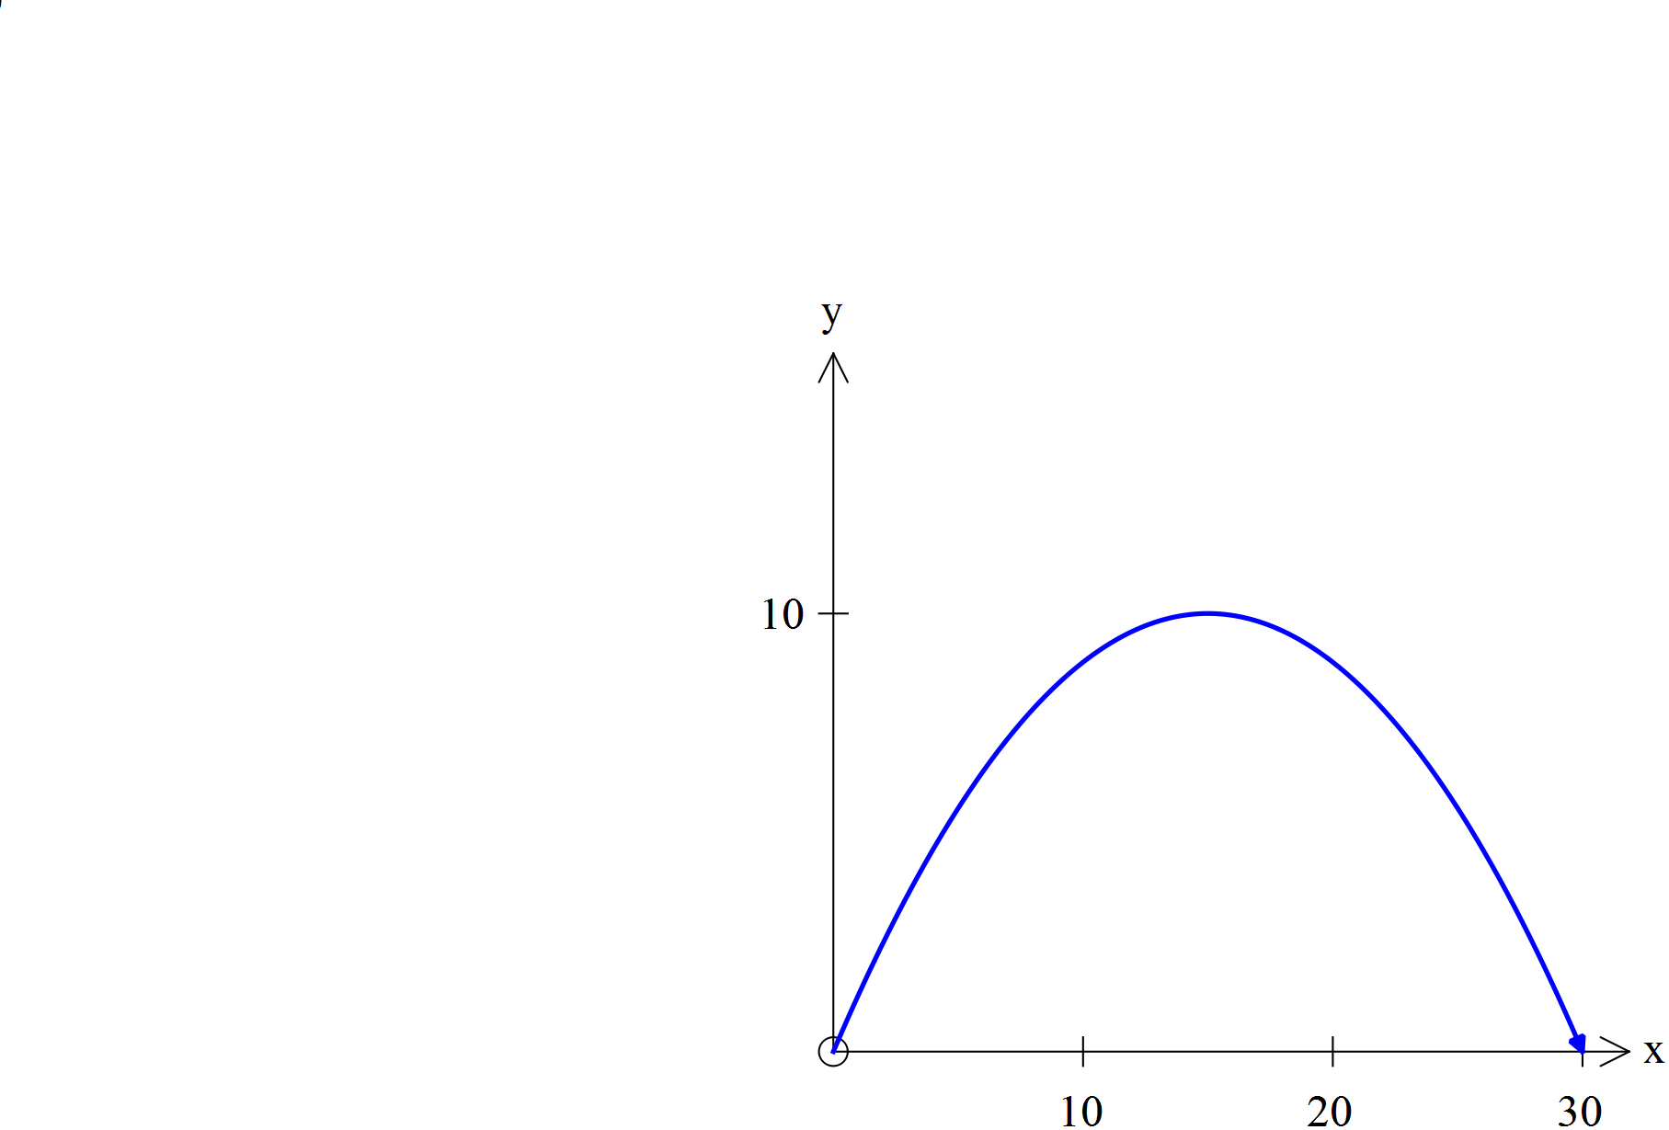

The diagram featured shows the path of the particle.

The equation of the path of P is $=\frac{4x}{3}-\frac{2x^{2}}{45}$.

**a)** State the position vector of P at time $t$ seconds.

**b)** Use vector methods to find the direction of the particle at time $t=1$ seconds .

**c)** Use vector methods to find the distance travelled by P along its path, from the time of the projection to the time it hits the $x$-axis again. Show clearly how you obtained your answer.

**7.** **[ 4 marks ]**

Prove that the line ***r*** = $〈3,0,2〉+λ〈2,2,-1〉$ is a tangent to the sphere with equation (x-2)2+(y-1)2+(z+1)2 = 10.

**8. [ 2,2,2,2= 8 marks ]**

Three particles A, B & C are such that their initial positions relative to the Origin at a given time are < 0, -1, -2> m ,

< 4, 1, 6 > m and < -4, 1, -2> m respectively. Their constant velocities are < 1, 2, 2 >ms-1, < -1, α, -2 > ms-1 and

< 3, 1, β >ms-1 , also respectively.

**a)** State the position vectors of each particle after *t*  seconds

**b)** If these velocities are maintained all three will collide. Use vector methods to determine the values of α and β.

**c)** If these velocities are maintained only A and B will collide. Use vector methods to determine the possible values of α and β in this instance.

**d)** If these velocities are maintained only two of the three will collide. Use vector methods to determine the possible values of α and β in this instance.

END OF TEST